**How to do Netbrain SNMP walk**

In order to make sure your Netbrain running properly and also easy for Netbrain support to troubleshooting, we have a SNMP walk tool can help to verify if SNMP works on the target devices , please follow below steps to do a SNMP walk for the devices, if it generates a non-blank text result, that means the SNMP string is working.

1. RDP to the server which hosts **NetBrain Network Server** (If your workstation have **SNMP access** to the switch, you can do this on your local machine as well).

**Or**

Download the [SNMPWalkTool](http://ws2.netbraintech.com/download/SNMPWalkTool.zip), and copy it to the server.

2. Launch the NetBrain **SNMPWalkTool.exe** with **administrator right**,

Set the management IP address of the device, and change SNMPWalk options:

**timeout** to **60 seconds**

**Repeate to 10**

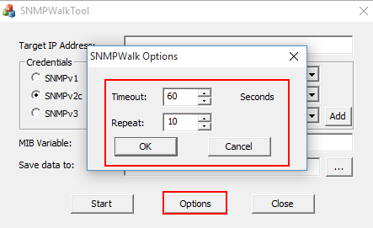

3. Select the right SNMP version and type SNMP community, then enter MIB Variable “**1.3.6.1**”. Save the data to your desktop and start the SNMP walk process.

4. The walk time depends on the hardware of device, and usually takes 1 – 10mins. Once the SNMP walk finished, please send the files to Netbrain support.